Million Dice Roll Statistics Simulator
Monte-Carlo • Exact DP • Visualization • Parameter Sweeps

Problem Statement
When you roll two six-sided dice the probability of a 7 is ~16.7 % while a 2 is only ~2.8 %. For three, four or a thousand dice the exact distribution becomes tedious to compute by hand. The original Project #46 asks the computer to roll N dice one million times and report empirical percentages. We extend the program so that any number of dice, any number of sides, exact theoretical probabilities, multiple implementation styles, and visual parameter sweeps are all available in a single reproducible notebook pair.

Solution Strategy
1. Core pure-Python loop that mirrors the book (pre-filled dict + progress every second).
2. Two alternates – collections.Counter and a NumPy vectorized matrix sum – that produce identical results many times faster.
3. Dynamic-programming recurrence that yields exact probabilities for any moderate N and S.
4. Matplotlib bar charts of the empirical distribution, an empirical-vs-theoretical overlay, and a multi-panel parameter sweep demonstrating the Central Limit Theorem.
5. Practice skeleton + fully worked solution notebooks plus flowchart so learners can implement first and check later.

Solution
Core API: simulate_dice_rolls, display_results, plot_distribution, simulate_with_counter, simulate_numpy, theoretical_probs, compare_empirical_theoretical, run_simulation_experiment.
Classic 2d6 (100 k rolls) reproduces the book percentages within sampling error (mode 7 ≈ 16.5 %). Exact DP recovers the familiar 1/36, 2/36 … 6/36 fractions. NumPy is ~18× faster on 200 k rolls of 3d6. A 4d6 experiment shows mode 14; a 1–10 dice sweep visualizes the rapid approach to normality.
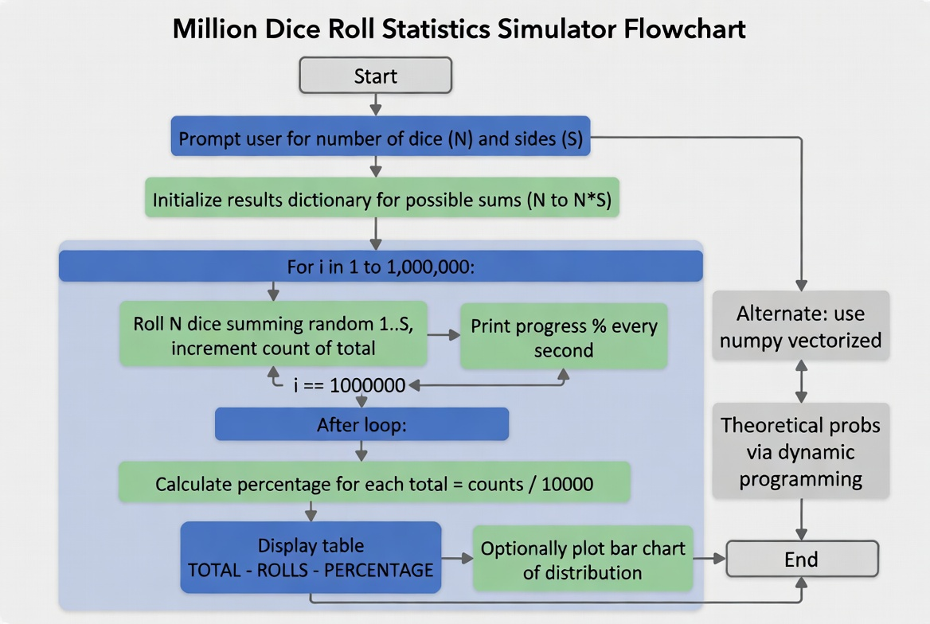
Program flowchart (core path + alternates)
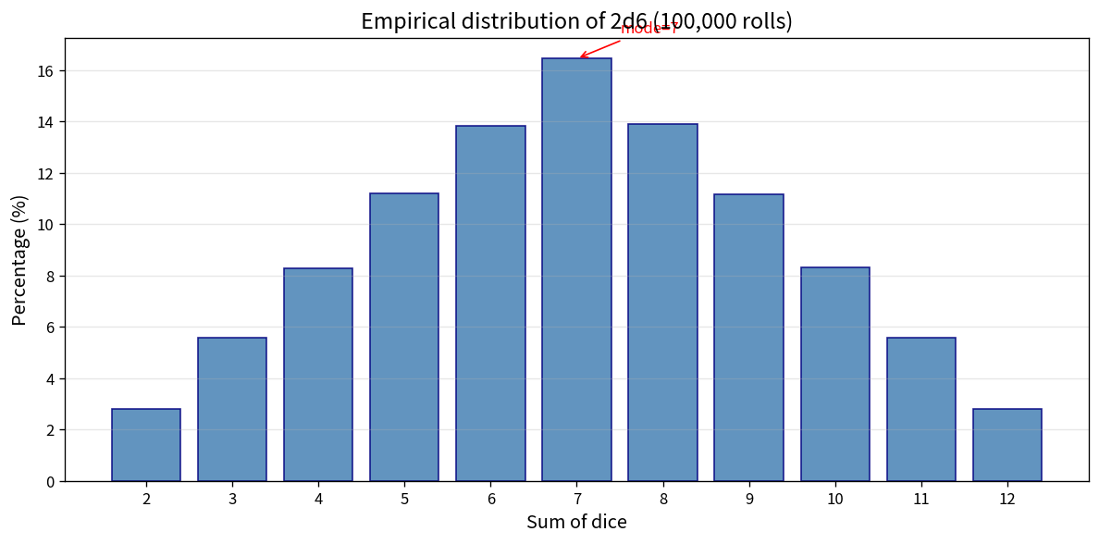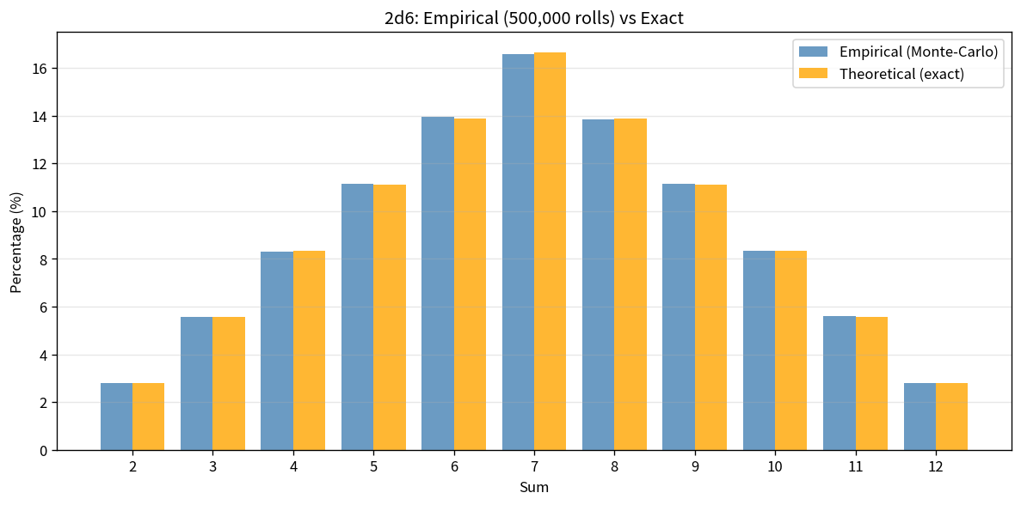
Left: empirical 2d6 histogram | Right: empirical vs exact probabilities
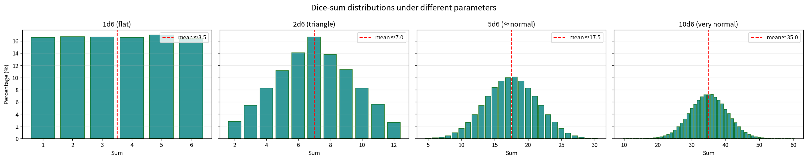
Parameter sweep: 1d6 → 10d6 shows the Central Limit Theorem in action

Key Takeaways
• Monte-Carlo simulation gives usable probabilities even when the analytic formula is cumbersome; 1 M trials already match theory to <0.1 pp.
• Pre-allocating a results dictionary (or using Counter / NumPy) keeps both clarity and speed; the vectorized version is an order of magnitude faster.
• Exact probabilities remain cheap via a classic DP recurrence for any practical number of dice and sides.
• The sum of independent dice rapidly becomes approximately normal – a concrete illustration of the Central Limit Theorem.
• Multiple equivalent implementations (loop / Counter / vectorized) let learners choose the clearest style for their audience.
Deliverables: Practice_Skeleton.ipynb • Solution.ipynb • flowchart & analysis PNGs • this 1-page report.

